**Practical No. 10**

**Aim: Configure IP routing using DHCP (Dynamic Host Configuration Protocol).**

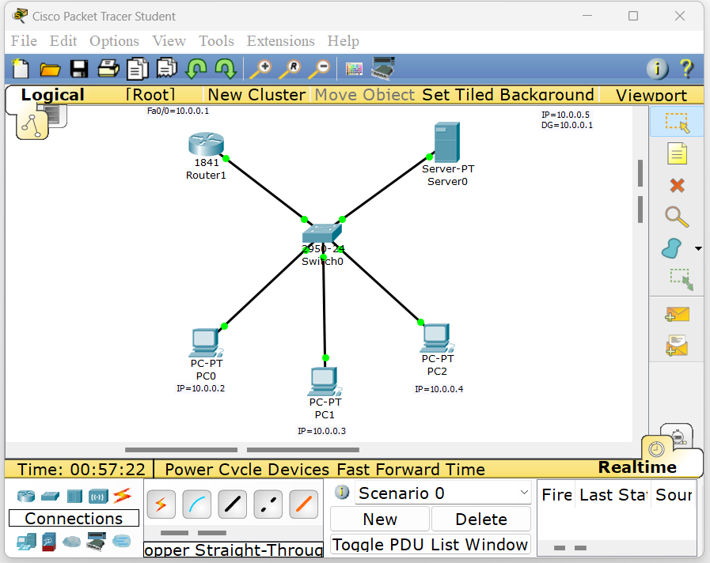

**Router 1.**

|  |  |
| --- | --- |
|  |  |

**Server 0. Pc 0.**

|  |  |
| --- | --- |
|  |  |

**Pc 1. Pc 2.**

|  |  |
| --- | --- |
|  |  |